Solve the enigma!
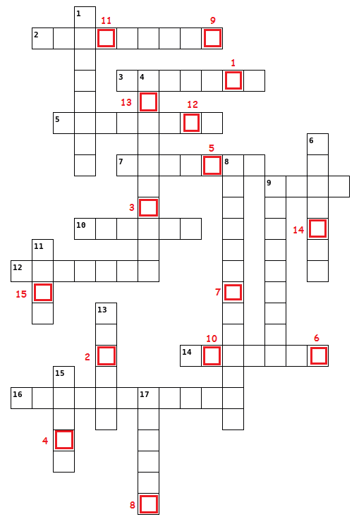 | 1) Complete the crossword with the words corresponding to these definitions
   | Across
  2. | The most famous district of Los Angeles where many film directors and actors work.
  3. | The English-speaking country whose capital is Kingston.
  5. | The name of the British Queen in the 19th century.
  7. | The family name of the writer of Oliver Twist.
  9. | The preterit form of the verb go
  10. | The capital of Australia.
  12. | The most popular means of communication in the 19th century.
  14. | The name of guides in American national parks.
  16. | The name of a famous American National Park situated in Wyoming.
   | Down
  1. | The English for "escalade".
  4. | The oldest population of Australia.
  6. | The comparative form of the adjective "funny".
  8. | The nationality of a person living in Wellington.
  9. | The name of the place where poor people had to live and work in the 19th century.
  11. | The superlative form of the adjective good.
  13. | The family name of a film director famous for his dark and fantastic films such as Sleepy Hollow, Alice in Wonderland, etc.
  15. | A synonym for the adjective "fat"
  17. | The past participle of the verb speak.

2) When you have finished, write the letters in red squares on the blanks to discover the subject of our new unit…
___ ___ ___ ___ ___ ___ ___ ___ ___ ___ ___ ___ ___ ___ ___
1 2 3 4 5 6 7 8 9 10 11 12 13 14 15
- Regarde ensuite le document “solution crossword enigma” pour pouvoir copier le titre et les objectifs de la nouvelle séquence dans ton cahier.

